**MAULANA AZAD NATIONAL INSTITUTE OF TECHNOLOGY BHOPAL**

**DEPARTMENT OF CSE**

Name: Yashwant Patidar

Scholar Number: 191112243

Section: CSE 2

3rd SEM BTech

Subject: Principles of Programming Languages Lab - CSE 219

**Lab Assignment**

**Question 1:** WAP to print the total surface area and volume of a cylinder by creating a class named “cylinder” with a function to print the area and volume.

**Program code:**

#include <iostream>

#include <math.h>

using namespace std;

#define _USE_MATH_DEFINES

class Cylinder{

    float r;

    float h;

    public:

    Cylinder(float radius, float height){

        r = radius;

        h = height;

    }

    float surfaceArea(){

        return 2*M_PI*r*(r+h);

    }

    float volume(){

        return M_PI*r*r*h;

    }

};

int main() {

    float r,h;

    cout<<"Enter radius and height of cylinder (in mm): ";

    cin>>r>>h;

    Cylinder c(r,h);

    cout<<"Total Surface Area: "<<c.surfaceArea()<<" sq. mm"<<endl;

    cout<<"Volume :"<<c.volume()<<" sq. mm";

}

**Output:**

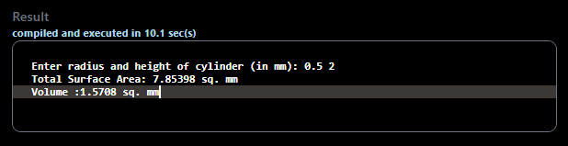

**Question 2:** WAP to print the volume of cones and cuboids by creating a class named “volume”. Height, radius and sides are passed as parameter to its constructor.

**Program Code:**

#include <iostream>

#include <math.h>

using namespace std;

#define _USE_MATH_DEFINES

class Volume{

    float r,h;

    float a,b,c;

    public:

    Volume(float radius, float height){

        r = radius;

        h = height;

    }

    Volume(float x,float y, float z){

        a=x;

        b=y;

        c=z;

    }

    float cone(){

        return M_PI*r*r*h/3;

    }

    float cuboid(){

        return a*b*c;

    }

};

int main() {

    float a,b,c,r,h;

    cout<<"Enter radius and height of cone: ";

    cin>>r>>h;

    cout<<"Enter sides of cuboid: ";

    cin>>a>>b>>c;

    Volume Cone(r,h);

    Volume Cuboid(a,b,c);

    cout<<"\nVolume of Cone is "<<Cone.cone()<<endl;

    cout<<"Volume of Cuboid is "<<Cuboid.cuboid();

}

**Output:**

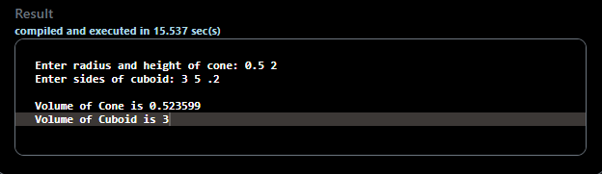

**Question 3:** WAP by creating an ‘Employee’ class having the following functions and print final salary: 1- ‘AddInfo()’ which takes the salary, number of hours of work per day of employees as parameters. 2 – ‘AddSal()’ which adds $10 to the salary of the employee if it is less than $500. 3 – ‘AddWork()’ which adds $5 to the salary of the employee if the number of hours of work per day is more than 6 hours.

**Problem Code:**

#include <iostream>

using namespace std;

class Employee{

    public:

    float sal;

    int hours;

    void AddInfo(float salary, int h){

        sal = salary;

        hours = h;

    }

    void AddSal(){

        if(sal < 500) sal+=10;

    }

    void AddWork(){

        if(hours > 6) sal+=5;

    }

};

int main() {

    float sal;

    int h;

    cout<<"Enter Salary of employee: ";

    cin>>sal;

    cout<<"Enter no. of hours of work per day: ";

    cin>>h;

    Employee E;

    E.AddInfo(sal,h);

    E.AddSal();

    E.AddWork();

    cout<<"\nFinal Salary of Employee: "<<E.sal;

}

**Output:**

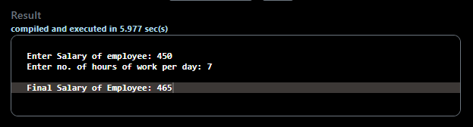

**Question 4:** WAP to print the roll number and average marks of 5 students in three subjects (each out of 100). The marks are entered by the user and the roll numbers are automatically assigned.

**Problem Code:**

#include <iostream>

using namespace std;

class Student{

public:

    int roll;

    int s1,s2,s3;

    float average;

    Student() {} //dummy constructor

    //parameterized constructor

    Student(int r,int sub1, int sub2, int sub3){

        roll=r;

        s1=sub1;

        s2=sub2;

        s3=sub3;

        average = (float)(s1+s2+s3)/3;

    }

};

int main() {

    int s1,s2,s3;

    Student* S = new Student[5];

    cout<<"Enter marks of students: "<<endl;

    for(int i=1;i<=5;i++){

        cout<<"\nRoll Number. "<<i<<"\nEnter marks of student: "<<endl;

        cin>>s1>>s2>>s3;

        S[i-1] = Student(i,s1,s2,s3);

    }

    cout<<"\n\nAverage marks:"<<endl;

    cout<<"Roll No.\tAverage"<<endl;

    for(int i=0;i<5;i++){

        cout<<"\t"<<S[i].roll<<"\t\t"<<S[i].average<<endl;

    }

}

**Output:**

